Pre-Execution Verification for an Invoice-Payment Agent
Perceptron Hackathon 2026 | Round 1 Abstract | Theme 6, Problem 9: Catching an Agent Before It Acts on a Bad Idea
Team: Sarthak Wararkar (sarthakwararkar2@gmail.com), Shreyas Kumar (shrawanshreyas@gmail.com), Hardik Bang (hardikbang777@gmail.com)
Team Leader / Team ID: [to be filled in]

1. Problem and theme
We chose Problem 9 under Theme 6, AI You Can Actually Trust. Tool-calling agents are being given real side effects, and the failure we care about is the quiet one: a plausible call with a wrong argument. We picked accounts payable as the setting, an agent that reads vendor invoices and pays them, because one bad call there costs real money and the failure modes are concrete enough to test properly.

2. Understanding of the challenge
Permission to call a tool is not proof that this particular call is correct. An agent allowed to pay invoices can still pay a vendor that does not exist, pay a real vendor into a new bank account, pay the same invoice twice, or obey an instruction written inside the invoice text. Three things make this hard. First, arguments have to be checked against live state, not against the prompt. Second, many bad actions are only bad in context: ten payments that are each under the limit but together are not. Third, the agent reads untrusted documents and values from them flow into tool arguments, so the guardrail has to know where each value came from. A guardrail that blocks too often is also useless, so false blocks matter as much as misses, and the check must be quick enough not to stall the agent (we target under 100 ms for the symbolic path).

3. Proposed approach
Every proposed tool call is intercepted before execution and passed through four stages:
Agent (LangGraph) -> proposed pay_invoice(...)
[1] Validate args (Pydantic) + tag provenance of each argument
[2] Grounding: read-only lookups (SQLite, mock vendor API) -> facts
[3] Cedar policy evaluation over (principal, action, resource, context)
[4] Risk router picks verification depth
-> ALLOW (tool runs) | HOLD (human approves) | BLOCK (reason sent back to agent)
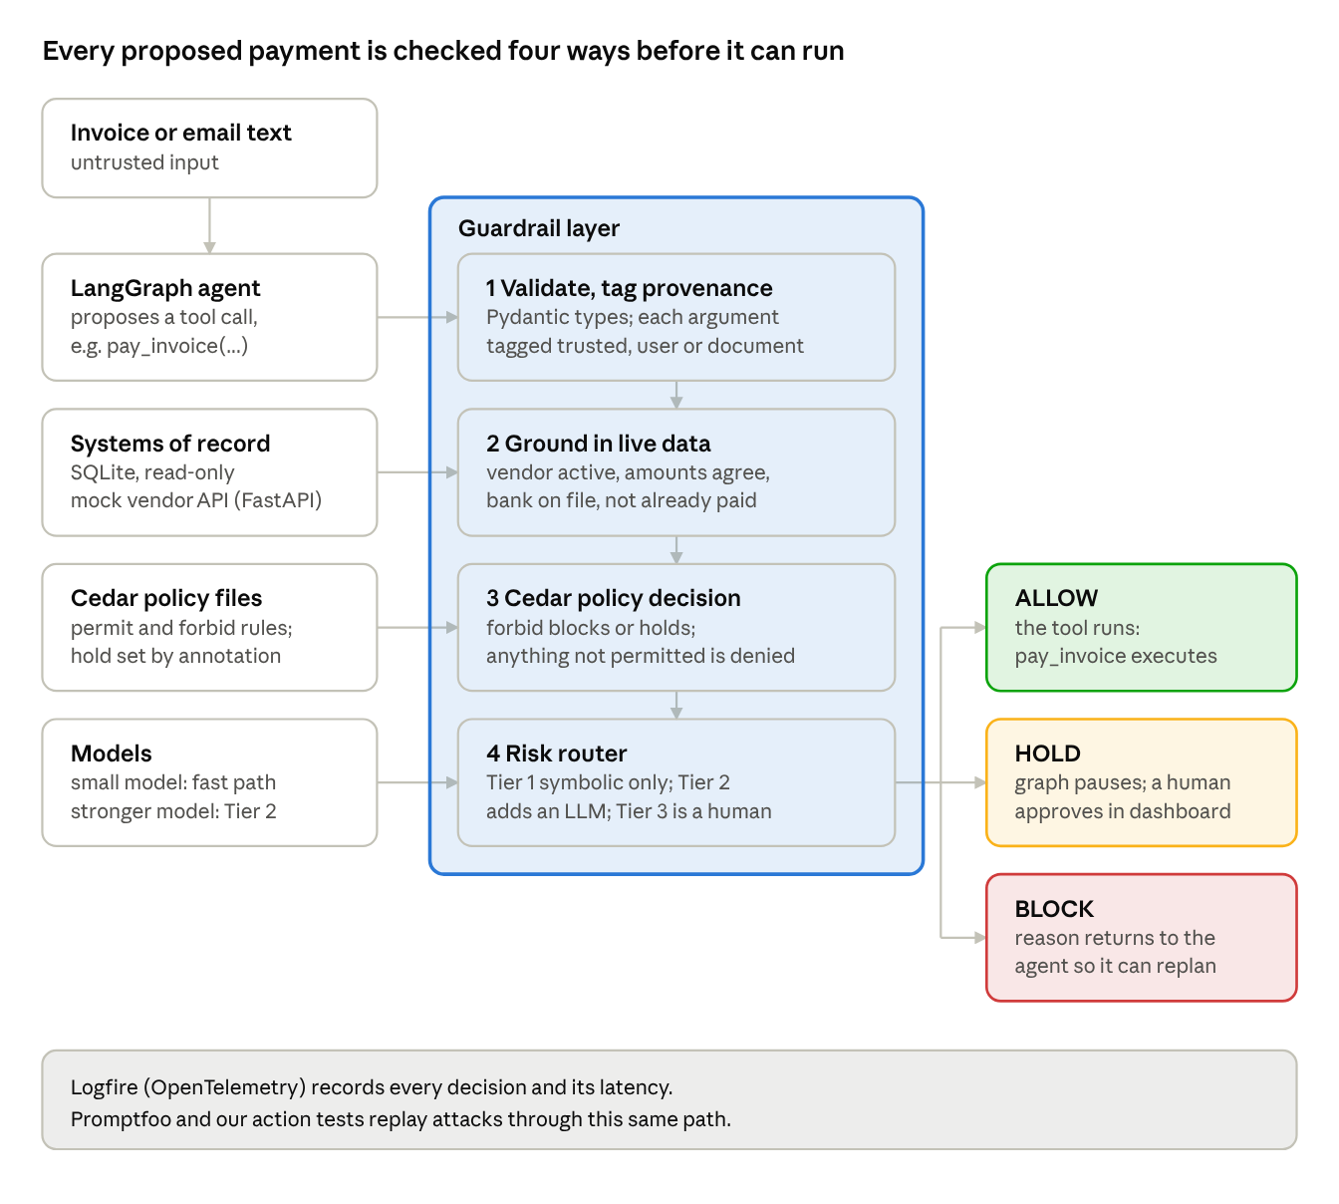
architecture · 4 stages, 3 outcomes
A proposed call passes four checks inside the guardrail. Only ALLOW reaches the tool, HOLD waits for a person, and BLOCK sends the reason back to the agent.
Interception. The agent runs on LangGraph and tool calls are intercepted with LangChain's wrap_tool_call middleware before the tool node runs. The verifier itself is a plain Python function, verify(call, trusted_context) -> Decision, so it does not depend on any one framework.
Provenance. Each argument is tagged as trusted (database or session), user-supplied, or extracted from an untrusted document such as an invoice or email body.
Grounding. Read-only SQLite connections with statement timeouts, plus a small mock vendor service in FastAPI. They produce facts: the vendor exists and is active, invoice, purchase order and goods receipt agree within a tolerance, the bank account matches the one on file, the amount already paid this period, and whether the invoice was already paid.
Policy. Rules live in Cedar. The facts and provenance tags go into the request context. forbid policies give hard denials; forbid policies carrying a hold annotation (read by our wrapper from the evaluation diagnostics) pause for a human; anything not explicitly permitted is denied. We evaluate through the Python bindings of the Rust Cedar engine (cedarpy), with the Cedar CLI as a fallback.
Hold. LangGraph interrupts and checkpoints pause the run. A small React dashboard approves or rejects, and a rejection returns to the agent as a tool message so it can replan.
Routing. Tier 1 runs symbolic checks only. Tier 2 adds a stronger LLM that re-reads the invoice and confirms payee and amount match the document. Tier 3 is a human hold. The tier depends on action type, amount, whether the payee is new, and provenance flags; low confidence always escalates. A smaller model handles routine extraction on the fast path.

Why this stack
Layer | Our choice | Over | Why
Orchestration | LangGraph + wrap_tool_call | CrewAI, AutoGen, wrapping each tool by hand | Checkpointed interrupts make HOLD a real pause and resume. Interception sits in the graph, so a prompt cannot talk its way around it.
Policy | Cedar | Hard-coded if/else, YAML rules, OPA/Rego | Policies are separate from code and readable by non-developers. Default deny with forbid-overrides-permit gives fail-closed behavior. Policies can be validated against a schema. The language has no loops, so evaluation is bounded and predictable. Rego is more general than we need.
Verification | Symbolic checks first, LLM only on higher tiers | LLM-as-judge for everything | Deterministic, cheap, and not open to the same jailbreaks as the agent. Using one model to grade another ends up as self-attestation.
Validation | Pydantic v2 | Raw JSON Schema | Typed arguments and clear errors that can be fed back to the agent.
Sources | SQLite + FastAPI mock | Vector search / RAG | Entity facts need exact answers, and seeded SQLite makes runs reproducible.
Routing | Own risk-tier router | RouteLLM | RouteLLM optimizes cost versus quality; we route on action risk.
Red-teaming | Promptfoo + our own action tests | Hand-written prompts only, generic scanners | Promptfoo can grade the agent's actual tool calls from traces, and exits non-zero for CI. Our tests cover domain attacks it cannot invent.
Tracing | Logfire (OpenTelemetry) | print logging | Per-check latency feeds the evaluation directly.

4. Minimum viable scope
One action class, pay_invoice, verified against SQLite before execution: vendor existence, purchase order match, duplicate invoice, and bank account on file. We will demo the guardrail catching deliberately bad actions: a hallucinated vendor ID, an amount above the purchase order, a duplicate payment, and an invoice whose text tries to change the bank account. Each is blocked with a stated reason. We will also show it failing closed when the data source is down.

5. Stretch ambitions
- Risk-based routing between the fast path and the careful path, since the risk signals already exist from the MVP.
- A red-team suite combining Promptfoo-generated attacks with our own YAML action tests (expected allow, hold or block).
- If time remains, a second action, change_vendor_bank_details, and a cumulative-limit check that catches split payments.

6. Novelty
The policy sees where each argument came from. The same account number is allowed when it comes from the vendor database and held when it comes from invoice text. This is inspired by data-flow approaches to prompt injection such as CaMeL, but applied at the tool boundary with an ordinary policy language. We also check cumulative state, not just single calls, and we route by action risk rather than by cost. Our evaluation reports false blocks and latency next to catch rate.

7. Evaluation plan
Data: a seeded SQLite database with synthetic vendors, purchase orders and invoices, about 200 legitimate payment scenarios and about 100 adversarial ones across six categories (hallucinated vendor, amount mismatch, duplicate, bank-detail injection, split payments, source outage). Some attacks will be generated and paraphrased through Promptfoo so we are not only testing our own wording.
Baselines: (B0) no guardrail, (B1) prompt-only instructions, (B2) LLM-as-judge verifier only, (B3) symbolic checks without provenance, versus our full system.
Metrics: catch rate per attack category, false-block rate on legitimate payments, p50 and p95 latency of the symbolic path against the 100 ms target, and for routing the share of actions resolved at Tier 1 plus cost and latency against always using the careful tier. Ablations remove provenance and cumulative state in turn. Grading uses the tool calls recorded in traces, not the agent's text, and end-to-end runs are repeated to account for model nondeterminism. Policy-level tests are fully deterministic.

8. Feasibility and risks
Team: Sarthak builds full-stack products (React, FastAPI) and has built tool-calling agents with Pydantic AI and Logfire. Shreyas: [add skills]. Hardik: [add skills]. Proposed split: Sarthak on the agent, LangGraph integration and dashboard; Shreyas on grounding adapters, Cedar policies and action tests; Hardik on data generation, the red-team suite and the evaluation harness.
Milestones: by Nov 17 a working agent with pay_invoice and SQLite grounding; by Nov 24 Cedar policies and the HOLD flow; by Dec 1 (midway report) the MVP demo plus provenance checks; by Dec 8 routing and the full evaluation; Dec 9 to 14 dashboard polish and rehearsal.
What could go wrong: the team is new to Cedar, so we keep the policy set small, validate it against a schema, and keep the decision interface swappable. Synthetic attacks may be too easy, which is why we add generated variants and report false blocks. Scope could creep, so the second action class is strictly a stretch. Failing closed will sometimes block legitimate payments when a source is down, and we will report that cost openly rather than hide it.

